Week 8 – Activity 1

Factory Design Pattern Analysis (Simple Factory)

Overview
The provided code demonstrates the Factory Design Pattern by separating object creation logic from client code. Instead of the client directly instantiating concrete classes, a factory class is responsible for deciding which object to create at runtime based on input conditions.
This improves flexibility, maintainability, and loose coupling.

Factory Design Pattern Implementation

1️⃣ Factory Pattern in NamerFactory
The clearest implementation of the Factory Design Pattern appears in both NameUi.py and NamerConsole.py within the NamerFactory class.
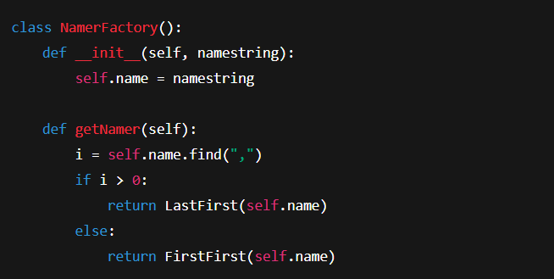

Explanation
- NamerFactory acts as the factory
- It decides which concrete class to instantiate:
  - LastFirst → if the input contains a comma
  - FirstFirst → if the input contains a space
- The client code does not know which class is created

2️⃣ Client Code Using the Factory
- From NameUi.py
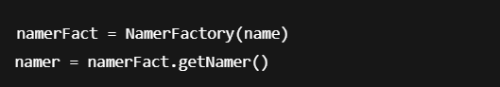

- From NamerConsole.py
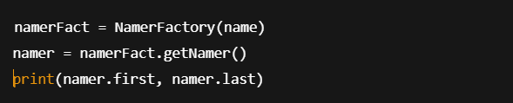

Explanation
- The client code interacts only with the factory
- Object creation logic is hidden
- The returned object follows the same interface (Namer)

Supporting Factory Example (Cocoon.py)
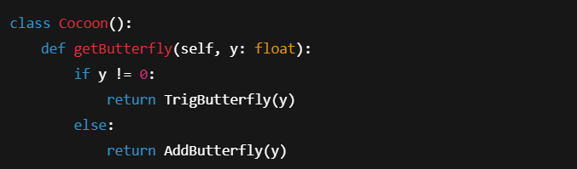

Explanation
- Cocoon acts as a simple factory
- It returns different Butterfly subclasses based on input
- This reinforces the same Factory pattern concept

Outcome of the Sample Code

Console Version (NamerConsole.py)

Input:

Output:

Input:
Enter name: Smith,John
Output:
John Smith

GUI Version (NameUi.py)
- User enters a name
- Factory selects the appropriate Namer class
- First name and last name fields are populated correctly

Advantages of Using the Factory Pattern
- Eliminates tight coupling between client and concrete classes
- Supports runtime decision-making
- Improves code readability and maintainability
- Makes it easy to extend with new name formats

Disadvantages
- Factory class must be modified to add new types
- Slight increase in complexity for small systems

Conclusion
The Factory Design Pattern is effectively implemented through NamerFactory and Cocoon, where object creation is centralized and hidden from client code. This allows the system to determine the appropriate class at runtime, improving flexibility and maintainability.

